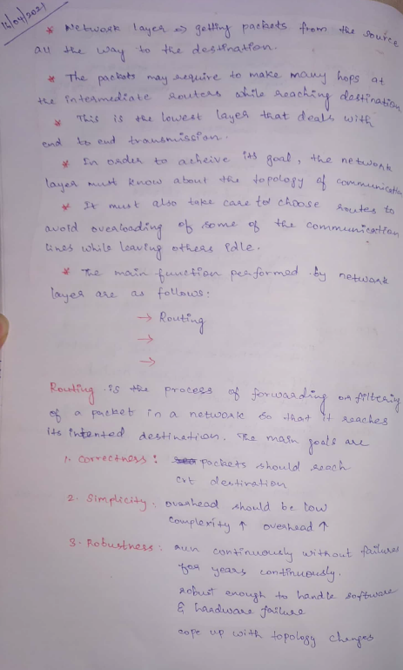 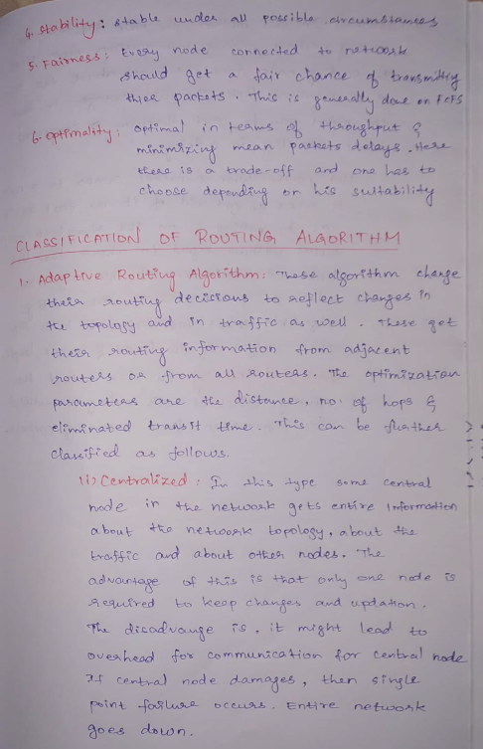

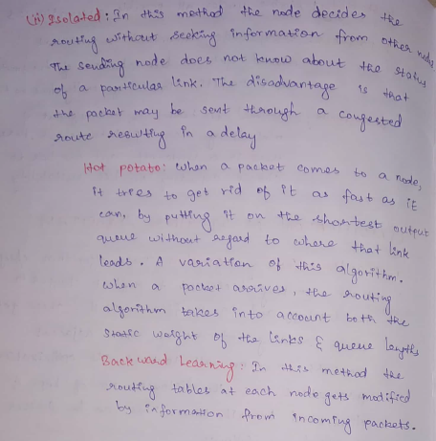

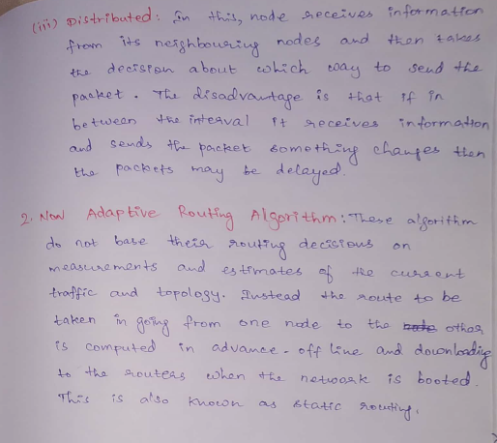

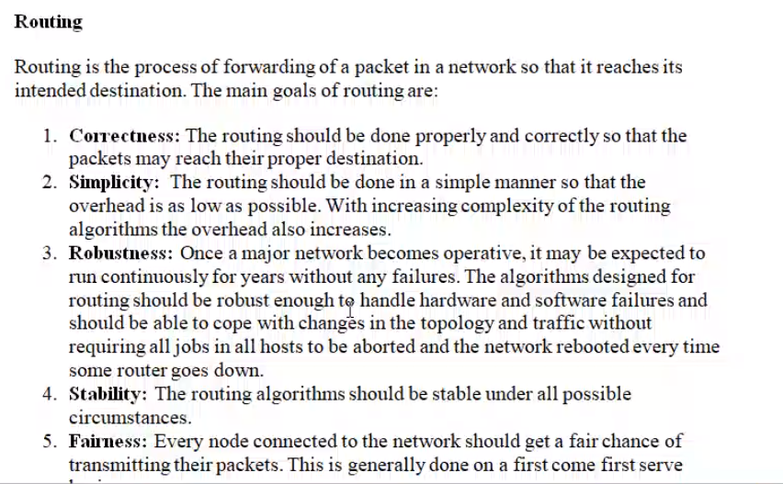

When two nodes (source and destination) are in same network 🡪 filter  
When two nodes (source and destination) are in different network 🡪 forwarding

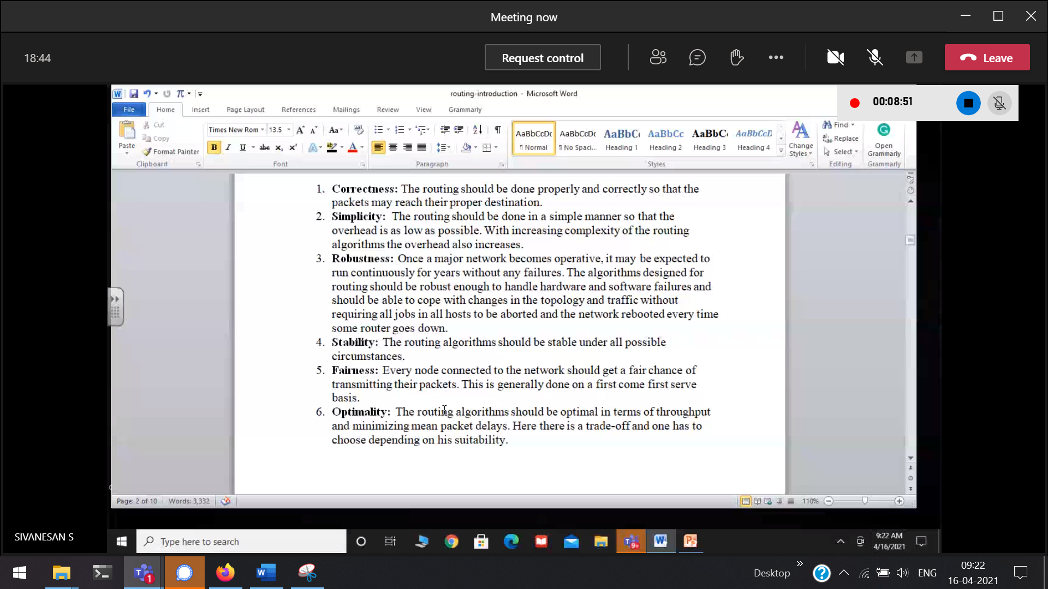

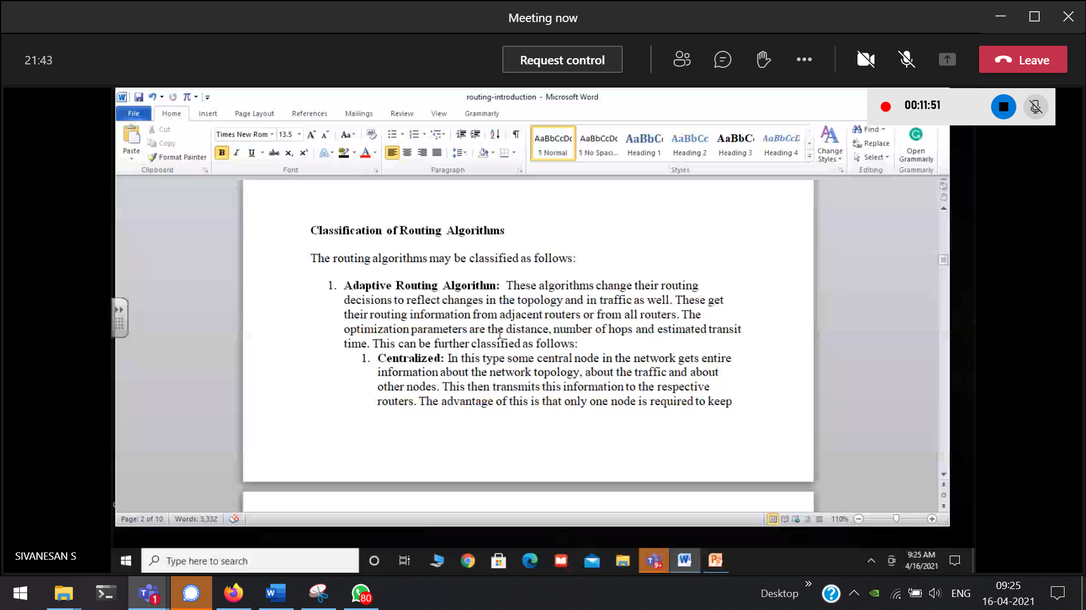

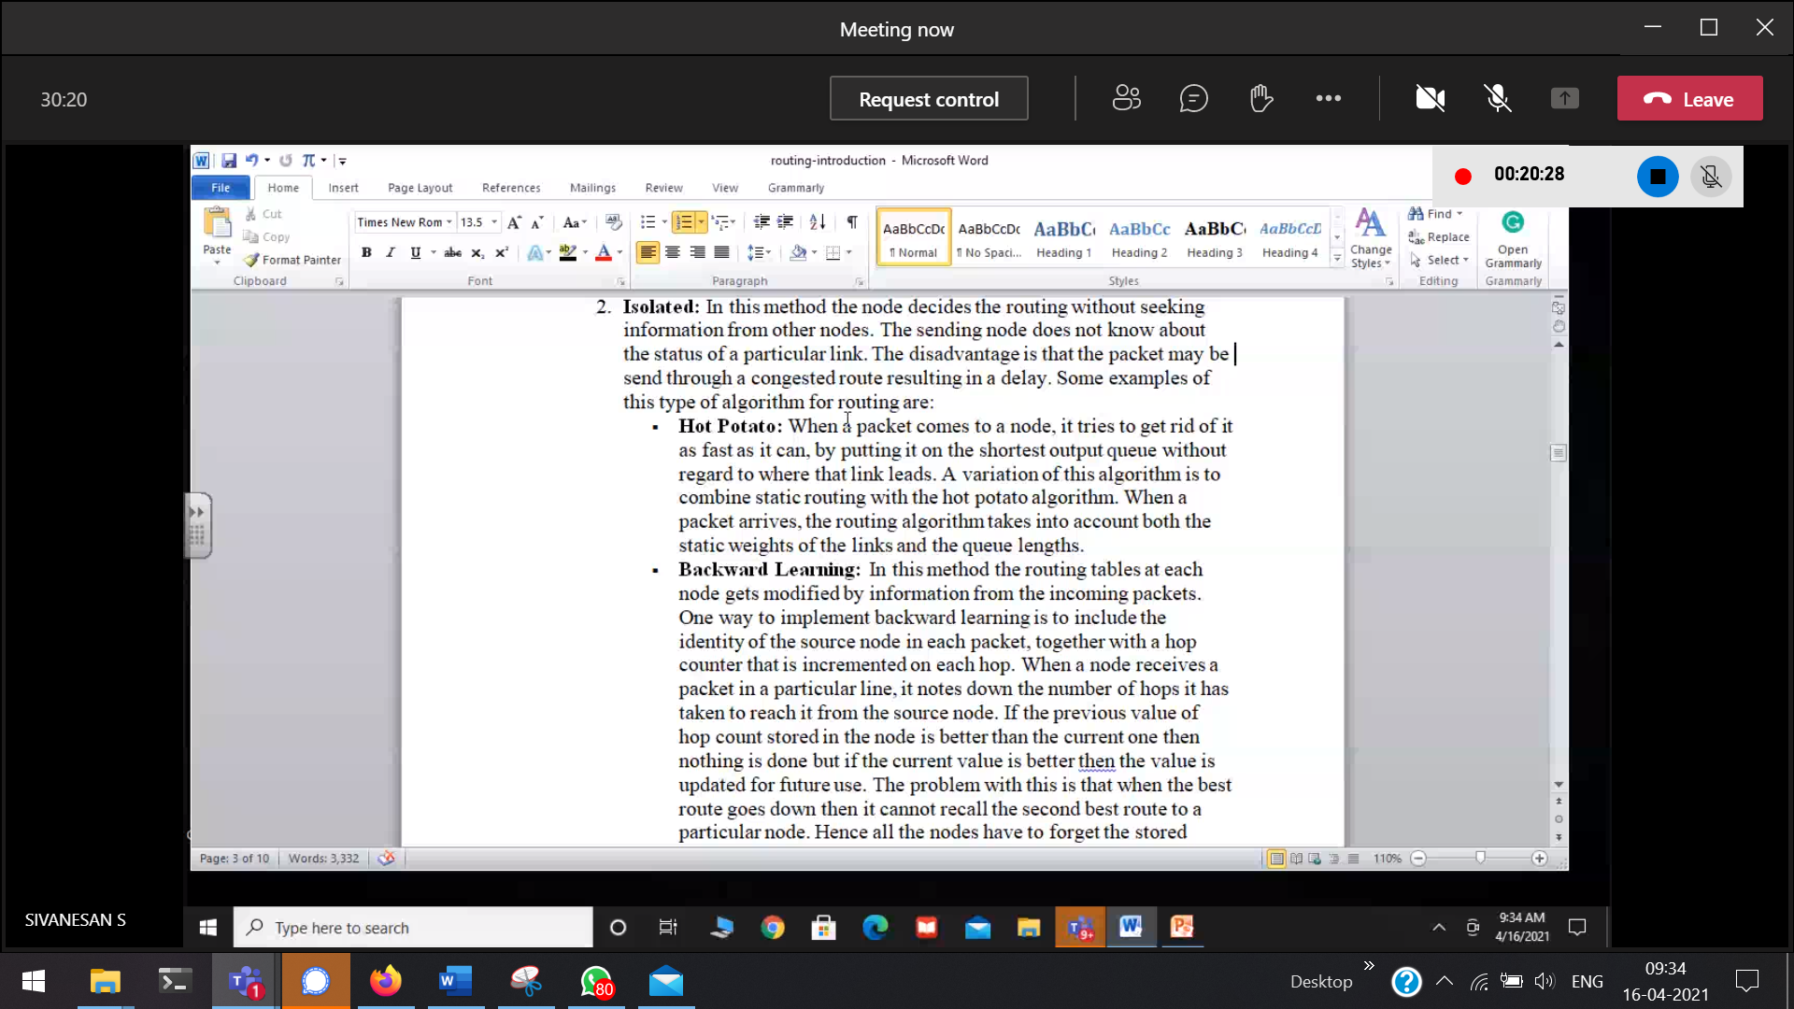

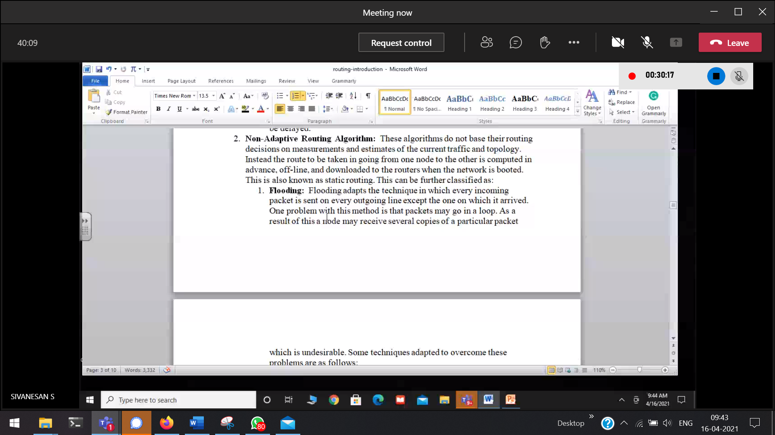

Adaptive 🡪 learning principle is there   
Non-adaptive 🡪 learning principle is not there

# Routing Algorithm

How to move a packet from a PC in one network to a PC in another network. This is done with the help of Routing.

## **Direct Delivery**

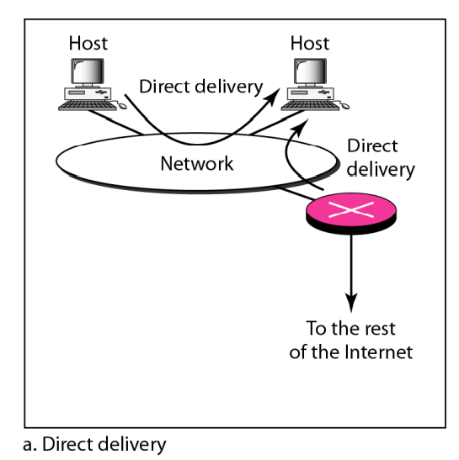

Both the hosts (source and destination) are in the same network. So they do not require any gateway routers(pink cross). The packets need not go out of the network.

## **In-Direct Delivery**

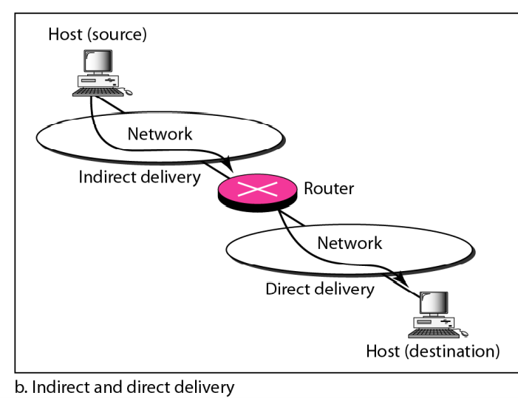

Source to its gateway-router.  
gateway-Router to its Source.  
Both requires Direct Delivery

# **Unicasting Routing**

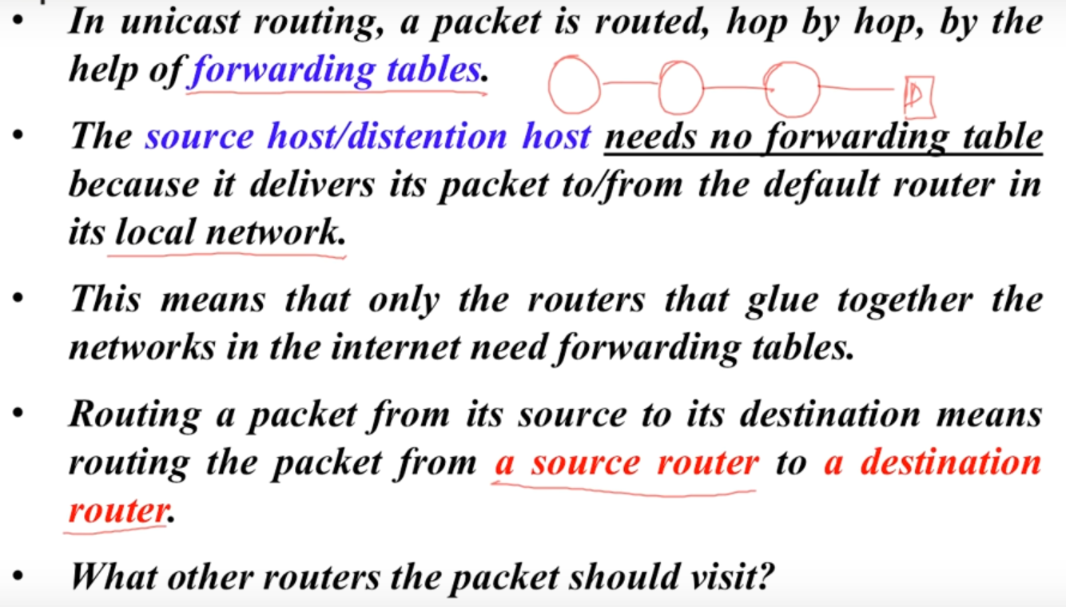

# **Least Cost Routing**

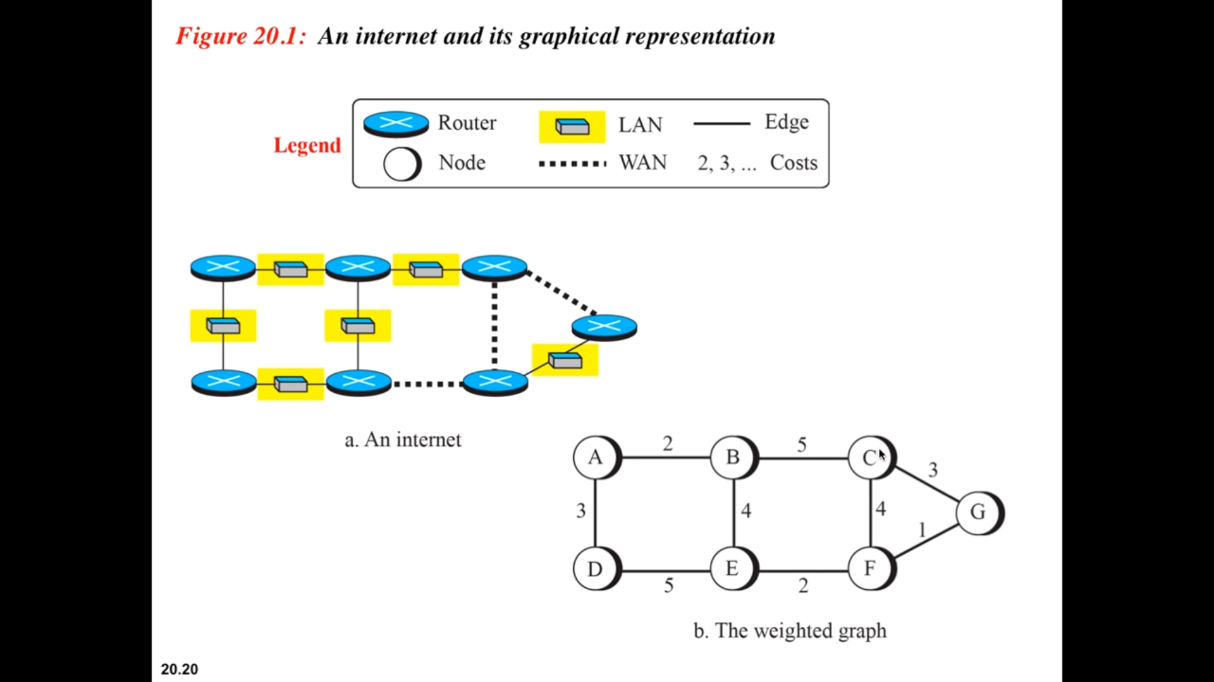

The internet is represented in the form of a weighted graph.

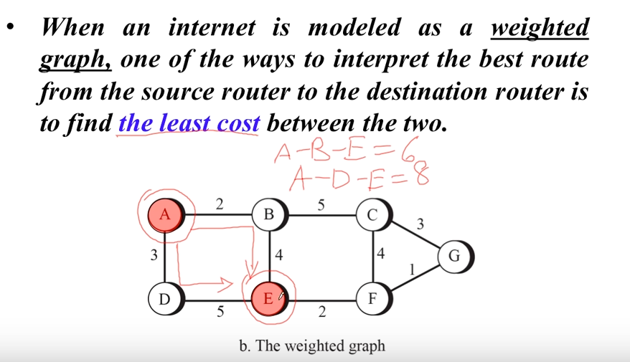

Direct neighbours 🡪 will always have the least cost.

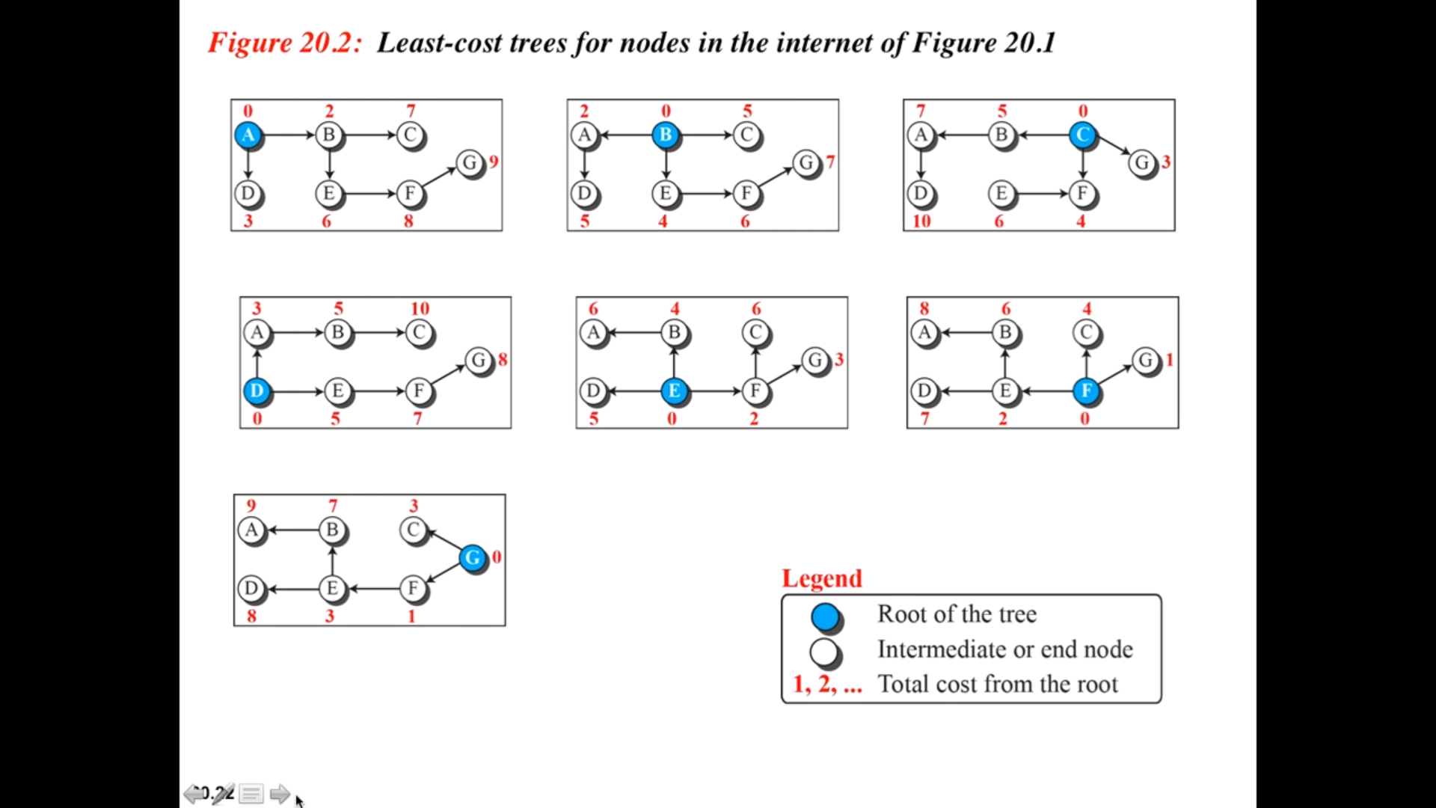

Shortest distance from the respective node.

# **Routing Protocols**

Routing protocol 🡪   
Routable protocol 🡪

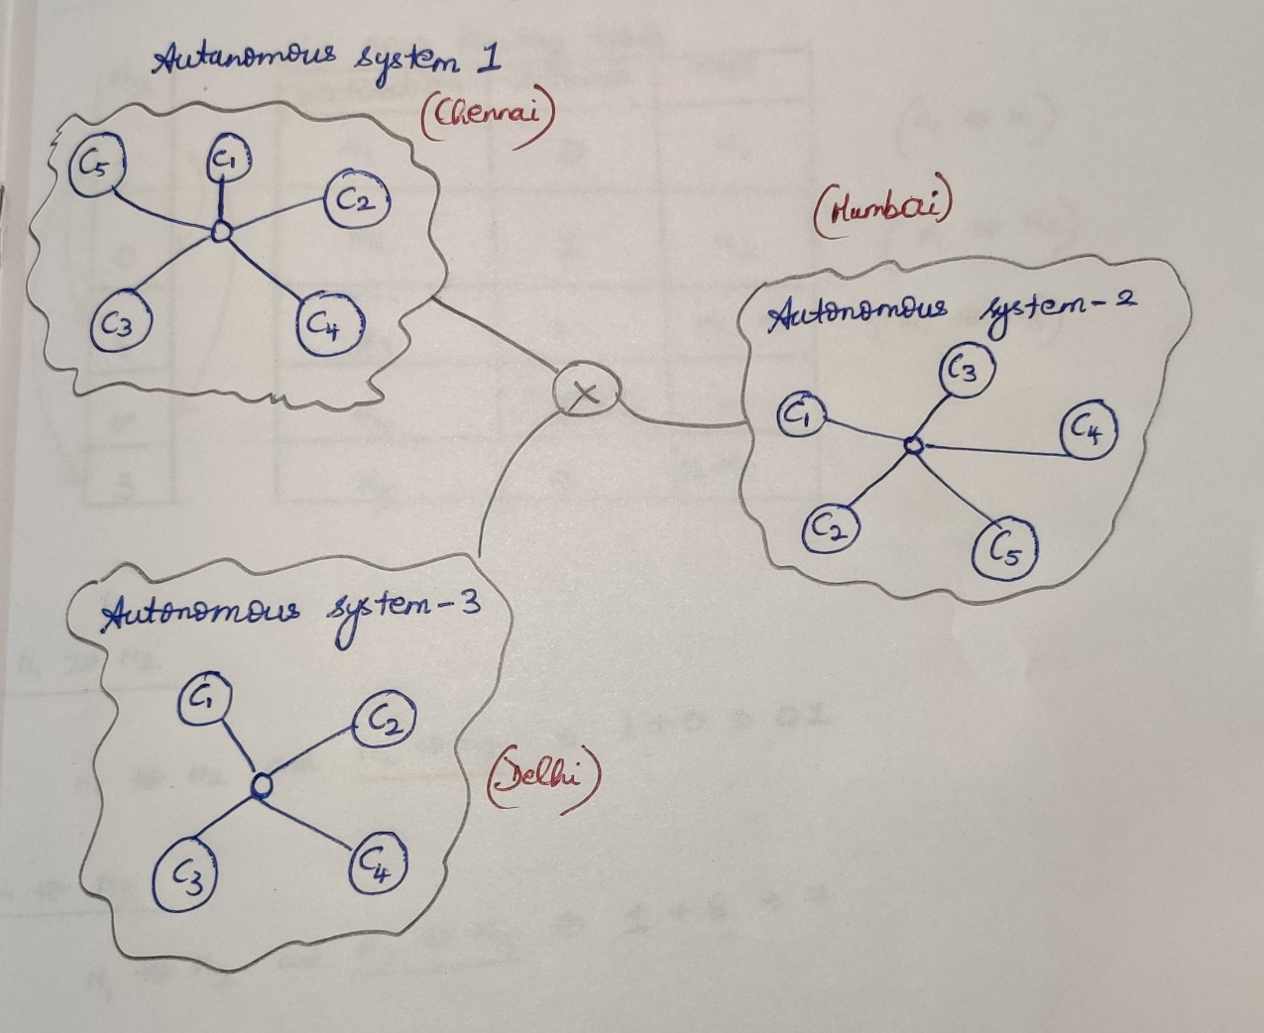

Intra-domain [Within a autonomous system] / Interior Gate-way Protocol  
Within Chennai / within Mumbai communication takes place.

Inter-domain [Between the autonomous systems] / Exterior Gate-way Protocol  
Chennai, Mumbai and Delhi are communicating with each-other.

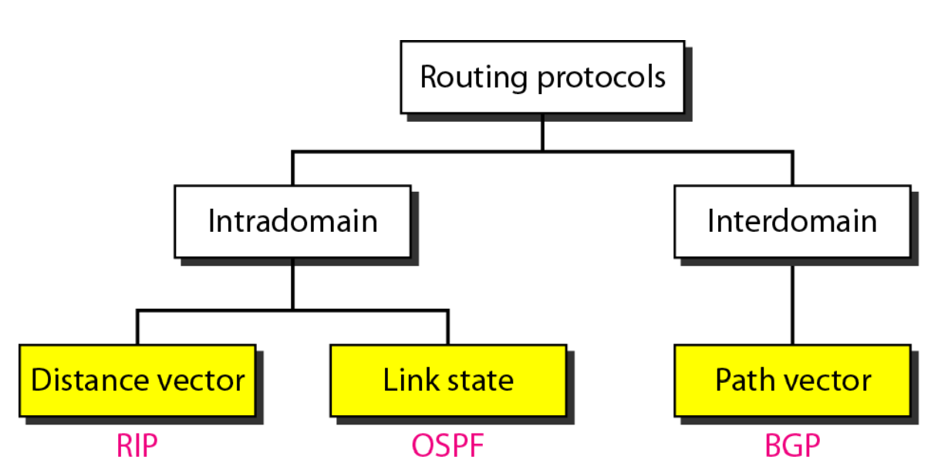

## **Intra-domain**

### **Distance Vector Routing [RIP 🡪 Routing Information Protocol]**

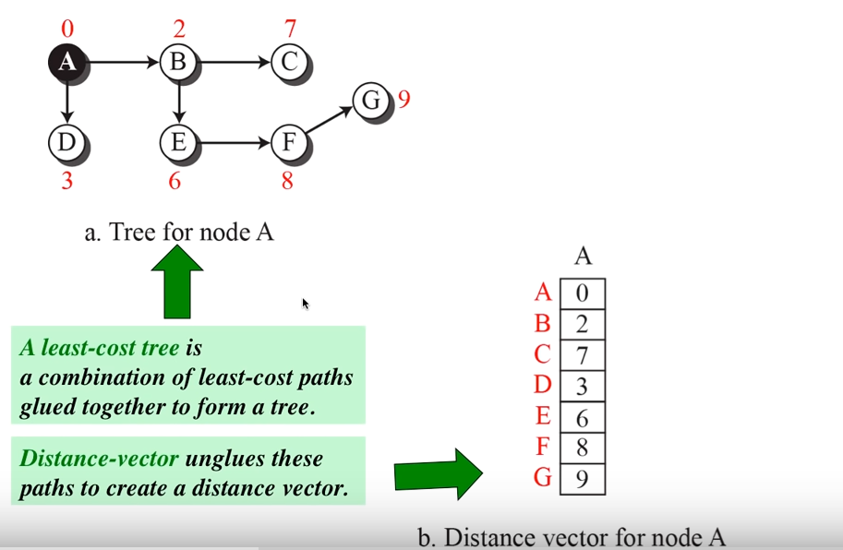

Neighbours will start to exchange information with each-other.  
This takes place in two different times.

If a router experiences some change in its vector, it will immediately inform to its neighbours about this change.

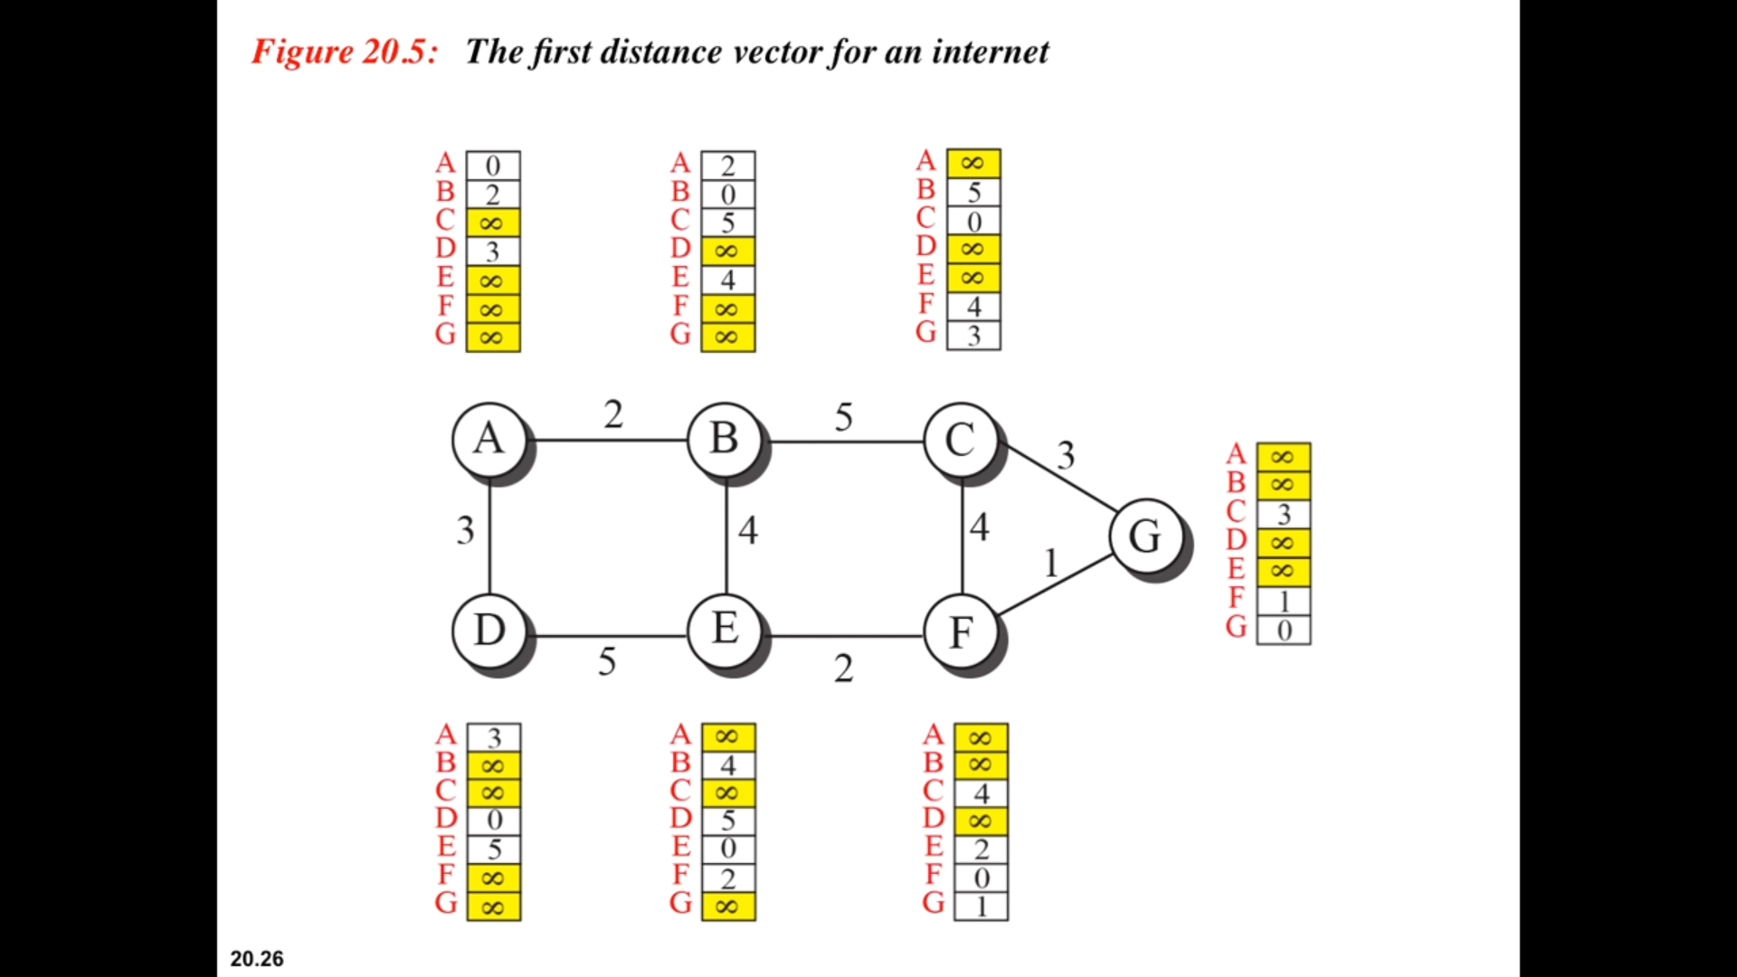

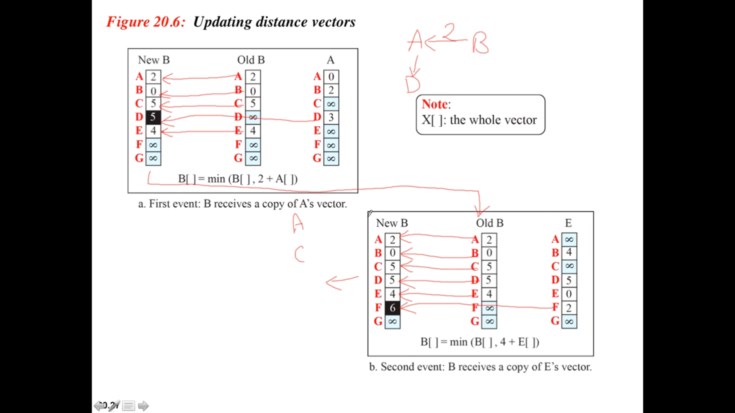

N1’s routing table

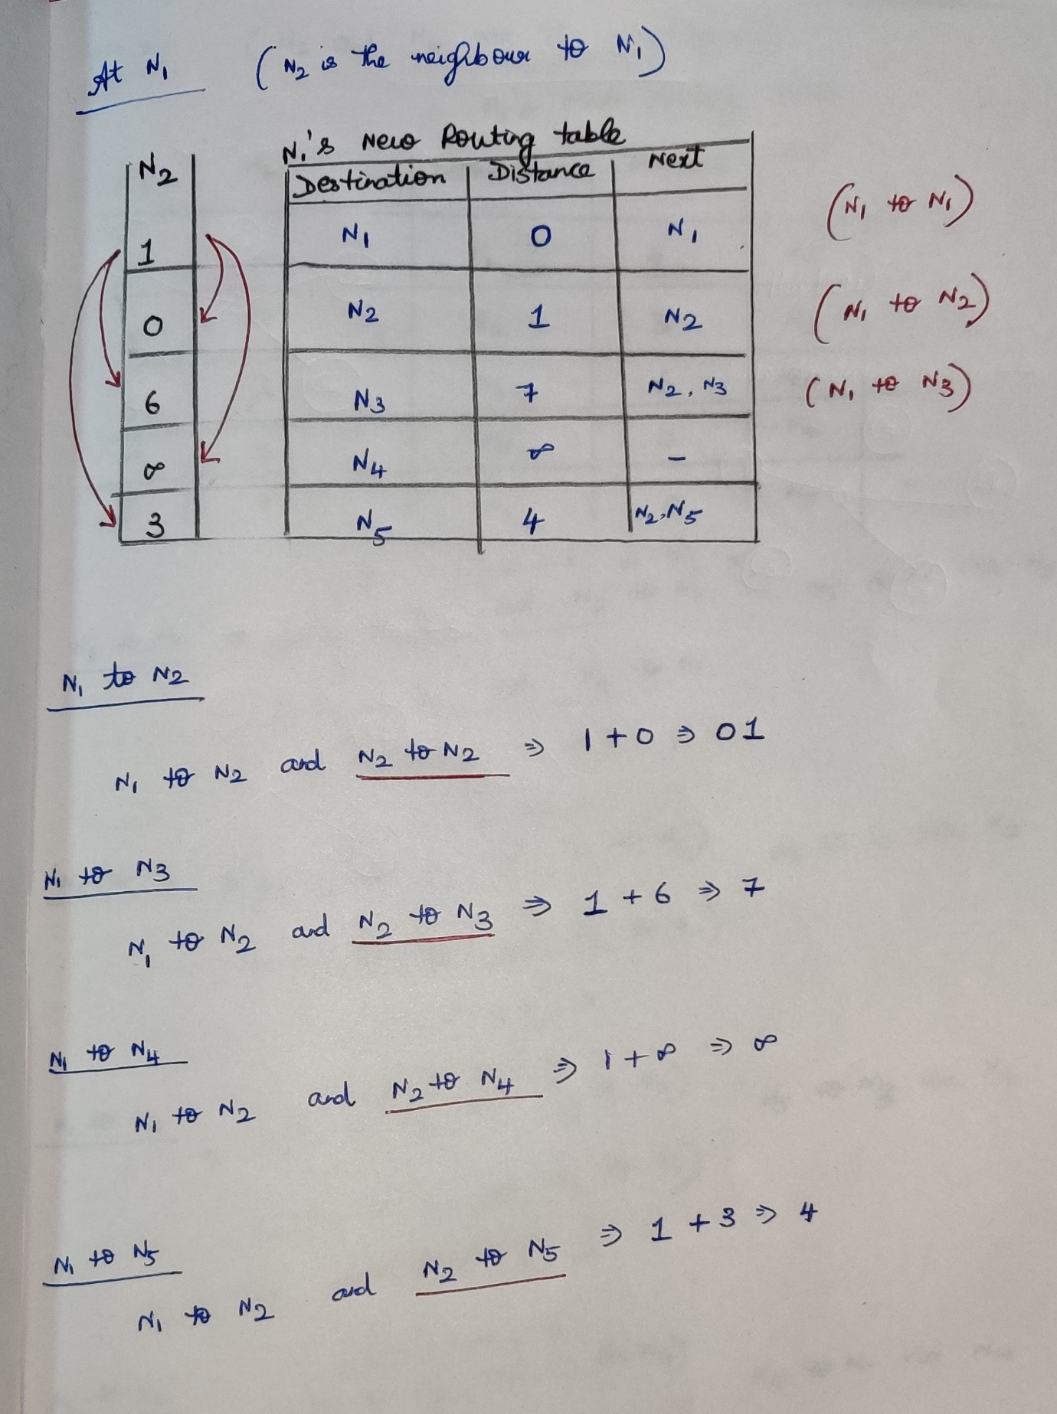

N5’s routing table

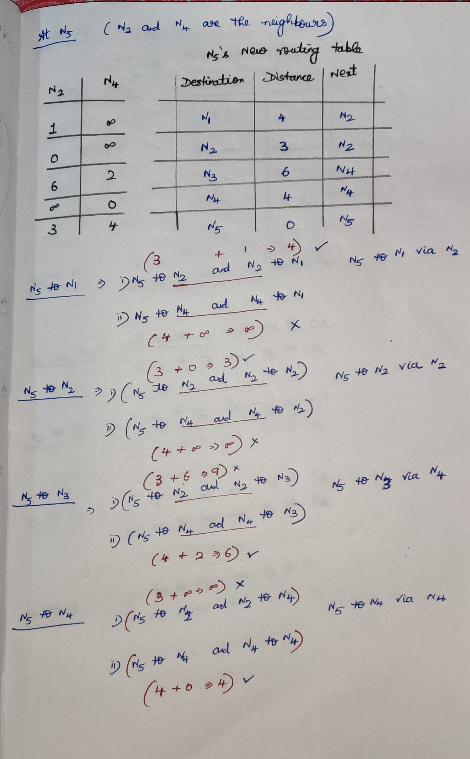

N4’s routing table

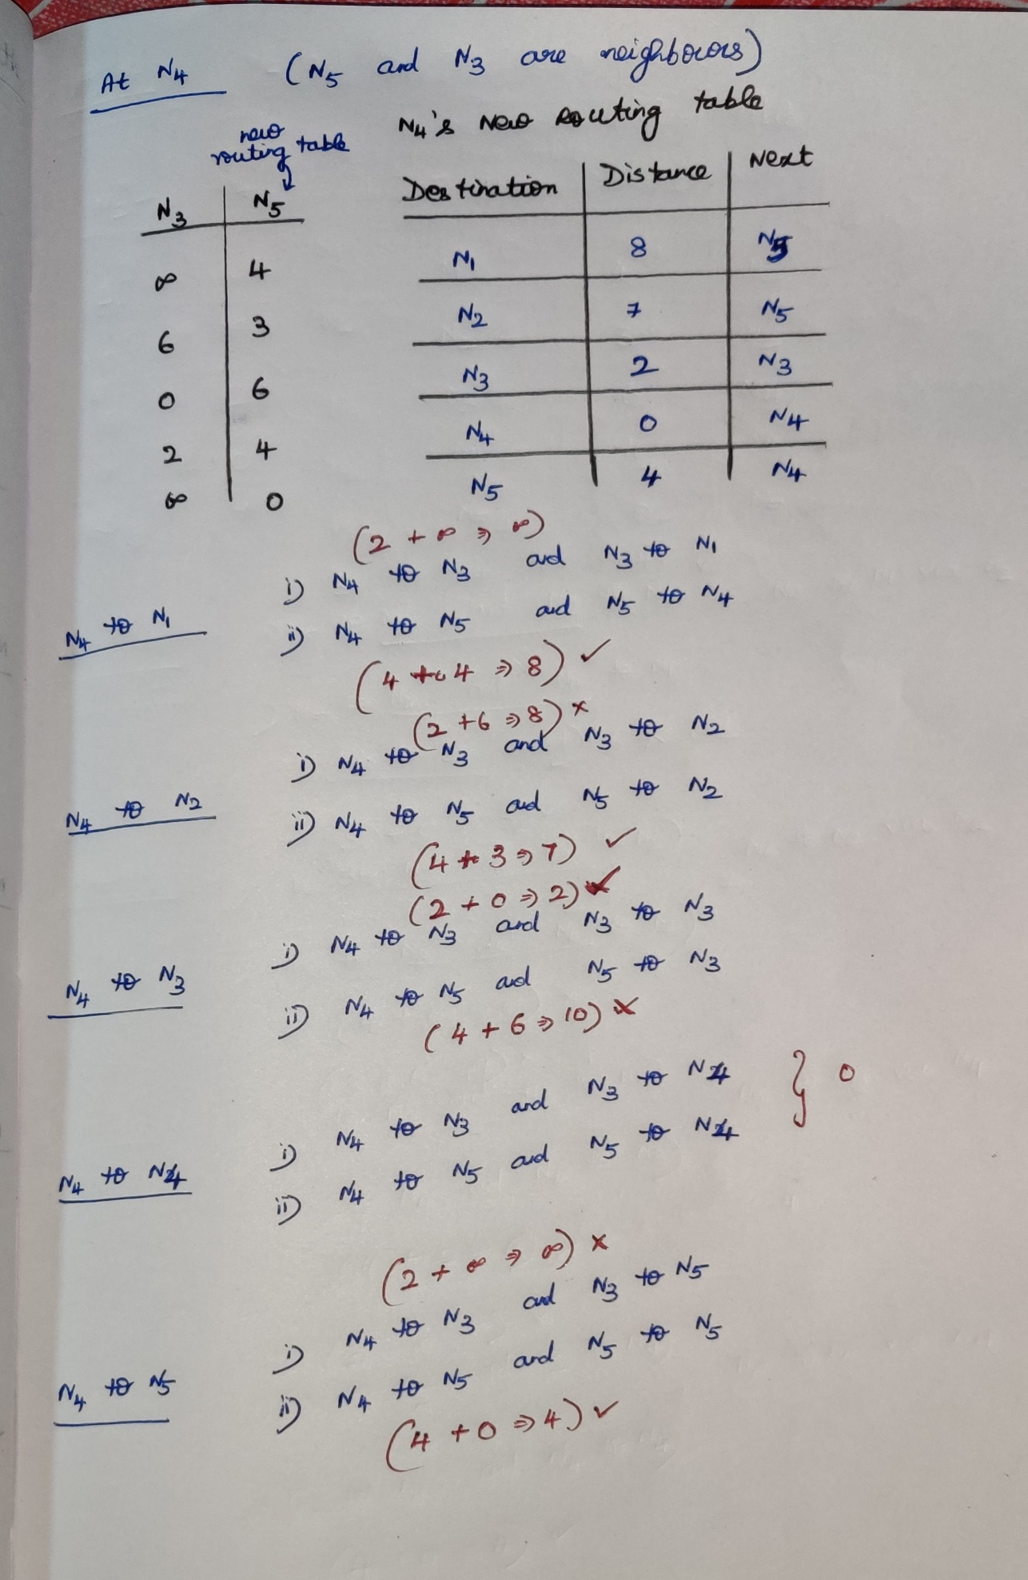

### **Link State Routing [OSPF 🡪 Open Shortest First Path]**

Link state routing uses Dijkstra’s algorithm.

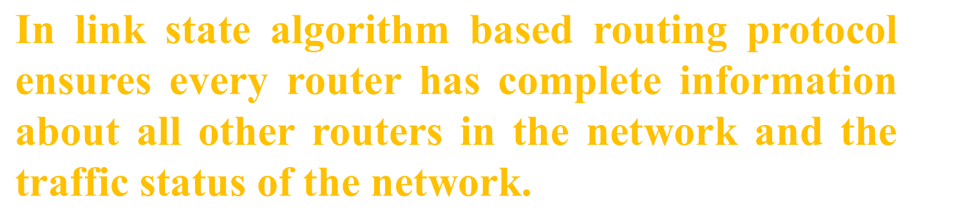  
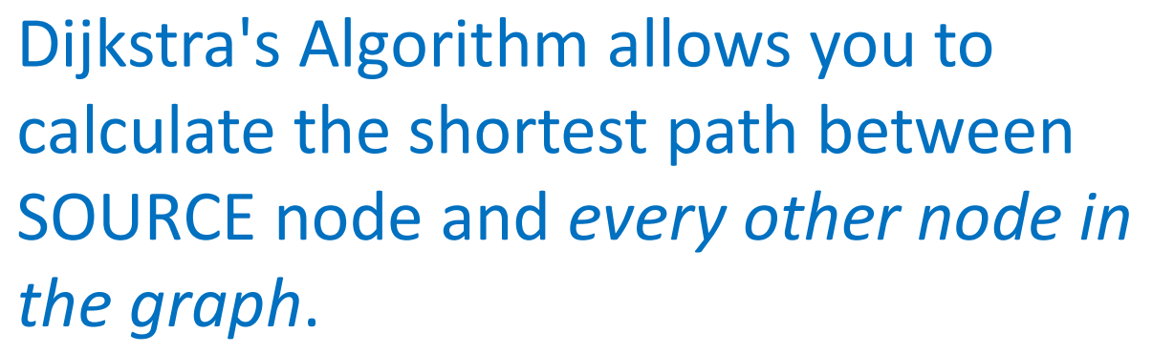

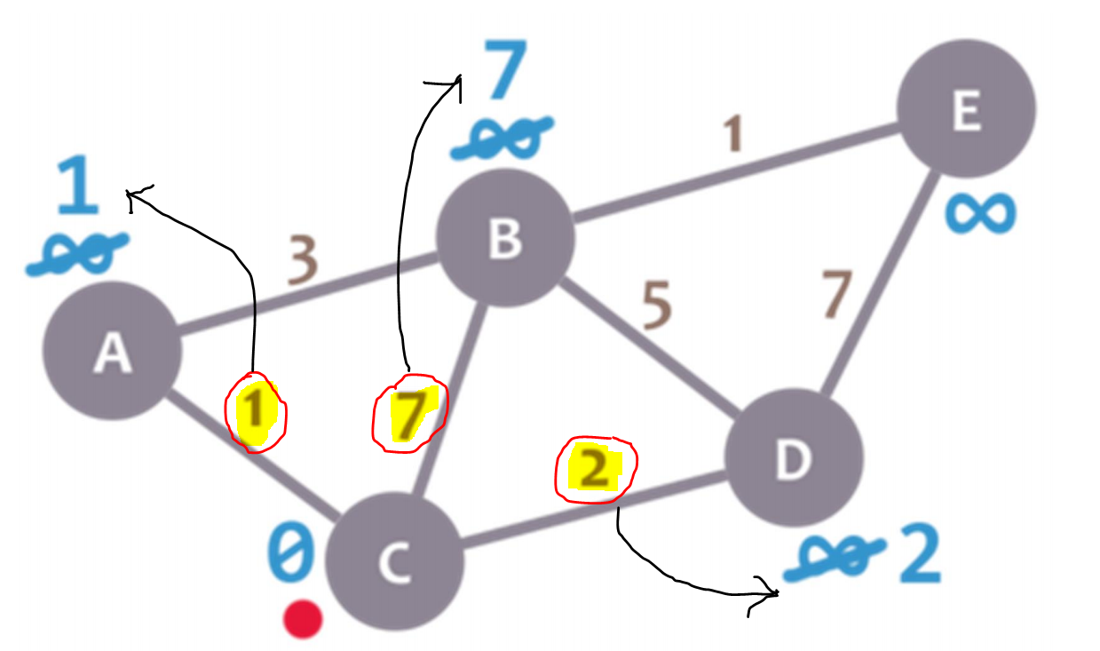  
For Node-C, A B D are the neighbours.

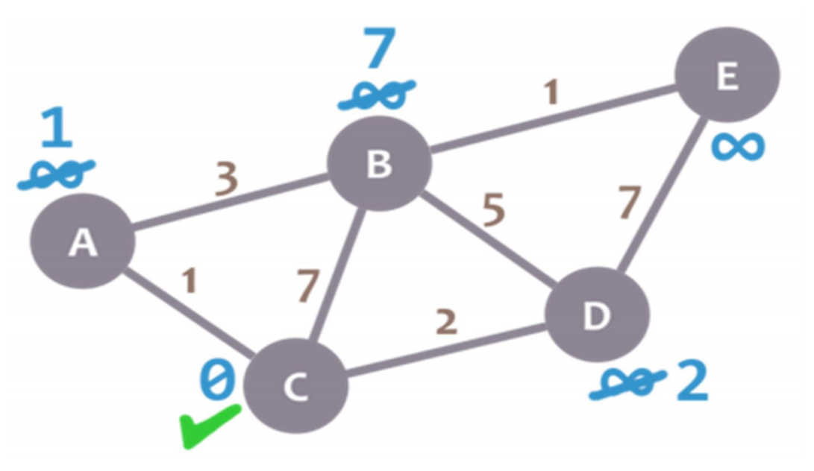  
C is visited, So no need to visit C again.

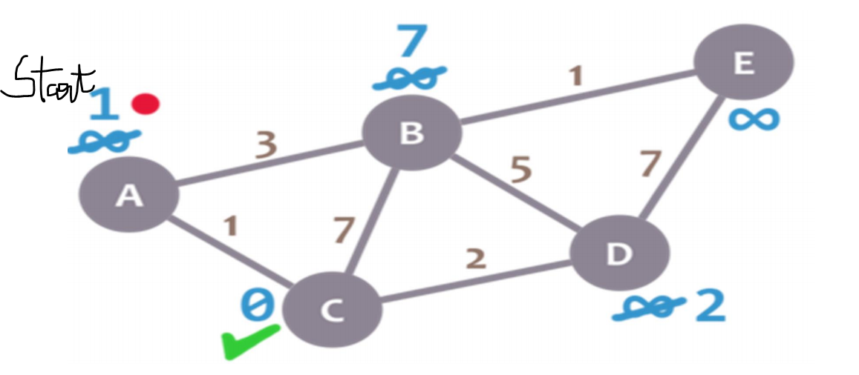  
Among A,B,D 🡪 A has the minimum distance. So starting node is A.

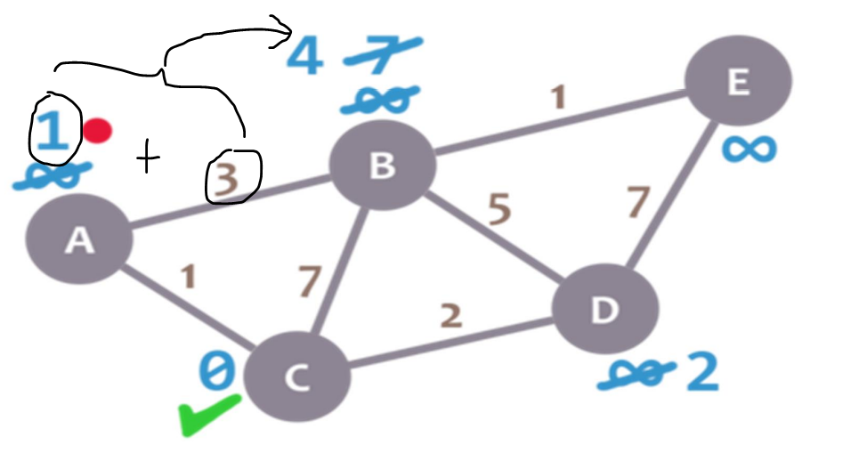  
Node-C is already done.  
C’s neighbour 🡪 A,B,D [A is visited] Still B and D are remaining.   
Among B and D 🡪 D is smaller, so going to visit D.

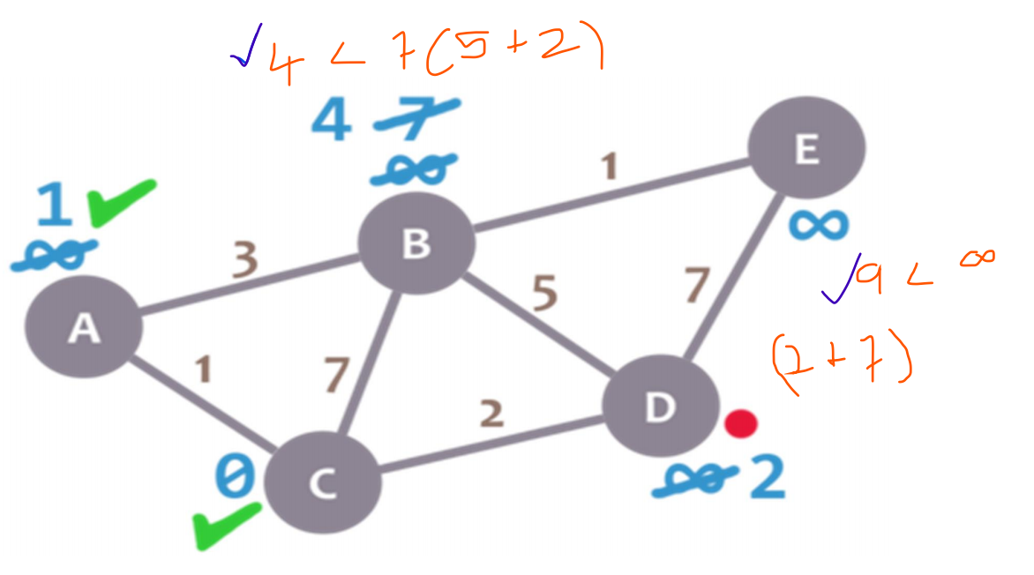  
So till-now A and C are visited.  
A is visited. B and D are still there. And Now going to visit D.   
For D, B and E are neighbours. Already B is 4, but from D is (2+5=7) (4<7) So keeping 4 for B.   
For E already inf, but from D is (2+7=9) (9<inf) So keeping 9 for E.

Go back C’s neighbour A,B,D [ A,D 🡪 done] still B is there. So going to start from B.

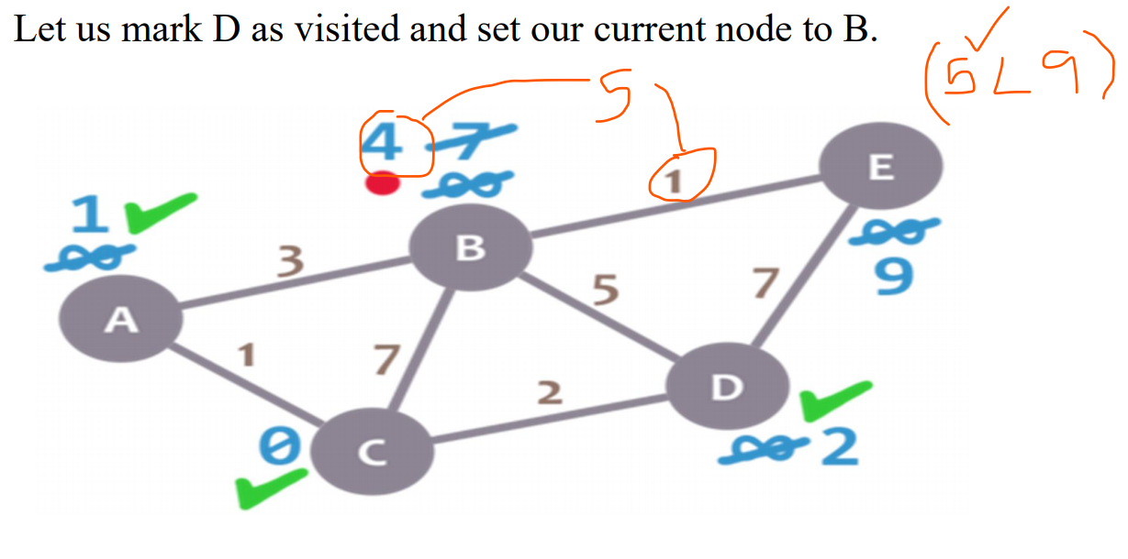

For B, only E is remaining. So (4+1) 5 < 9 🡪 5 is smaller.   
D’s, B’s neighbour 🡪 E. No going to visit E.

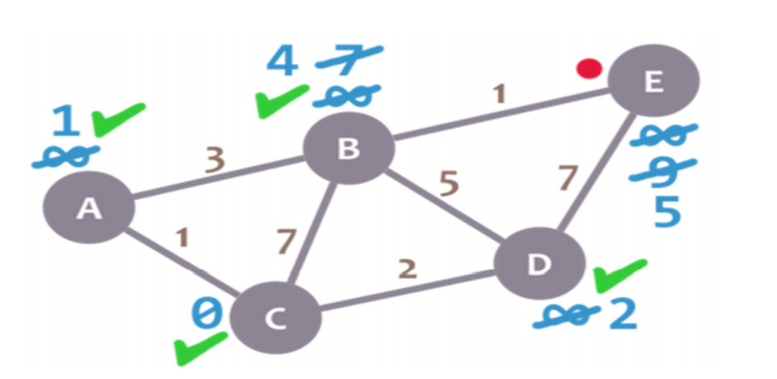  
For E all other nodes are visited. So stop the process.

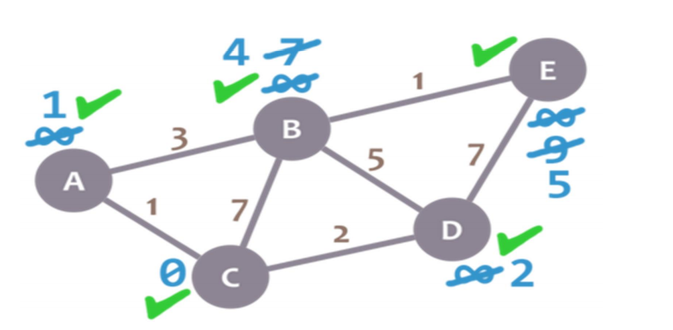

After finding the link-state information, it will flood that information to the entire network.

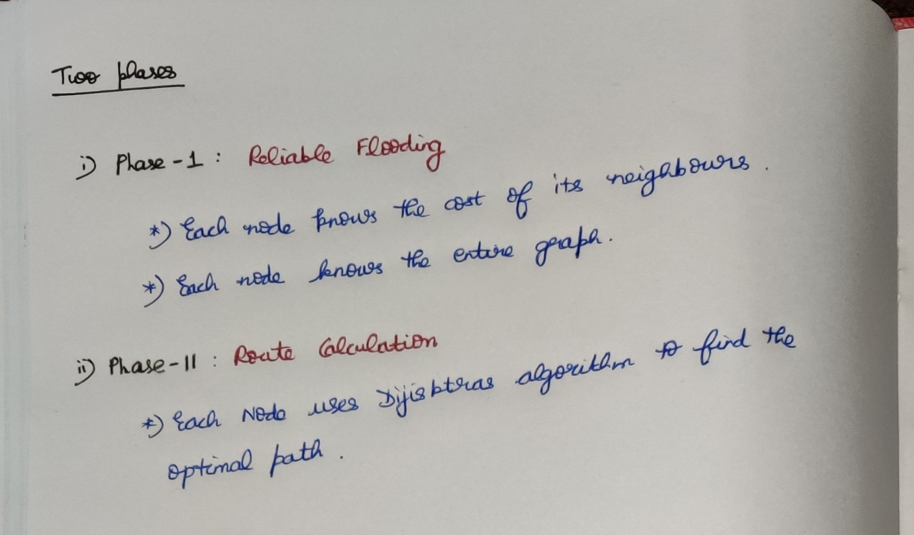

**Flooding**

* One router will send its *nearest neighbour information(link state information)* across the entire network.   
  Eg: A will send its neighbour information (i.e about C,B,D) to the entire network)
* Like this each and every node will send its nearest neighbour information across the entire network. So every router in the network knows the information about all other routers in the network.  
  Eg: A will know the information about B,C,D,E,F.

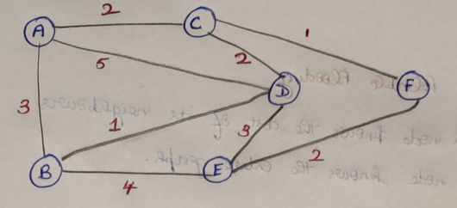

**Phase-1 Reliable Flooding**

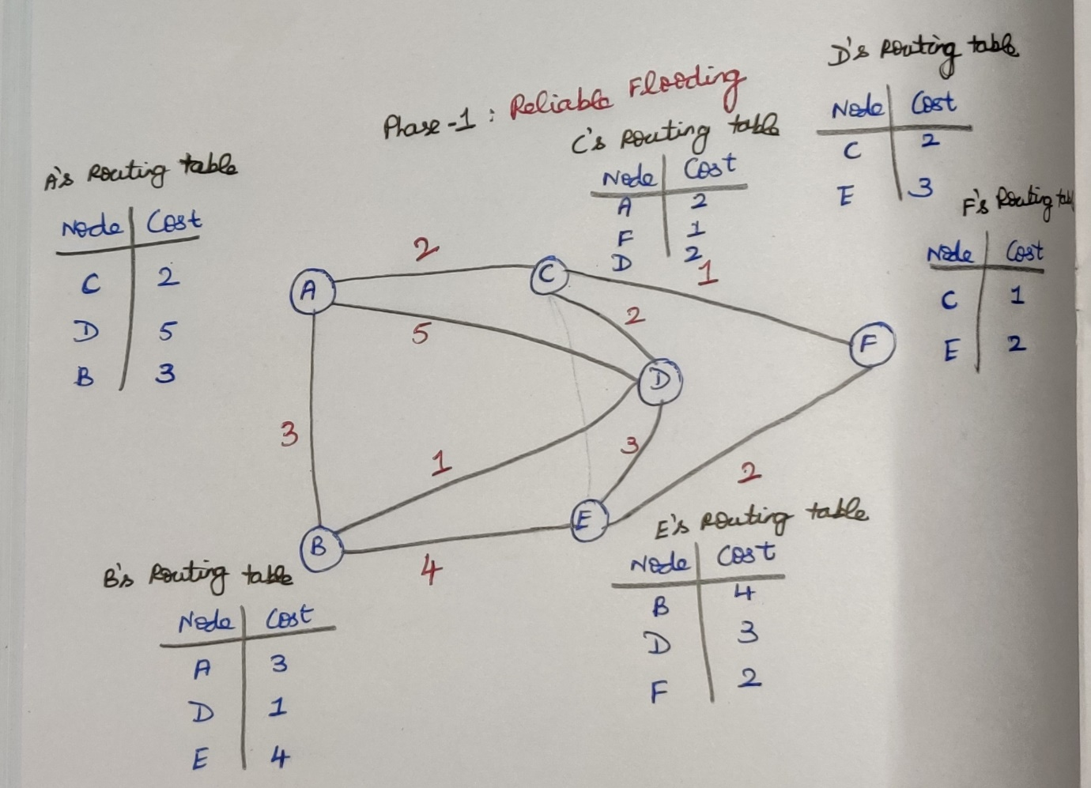

**Phase-2 Route Calculation**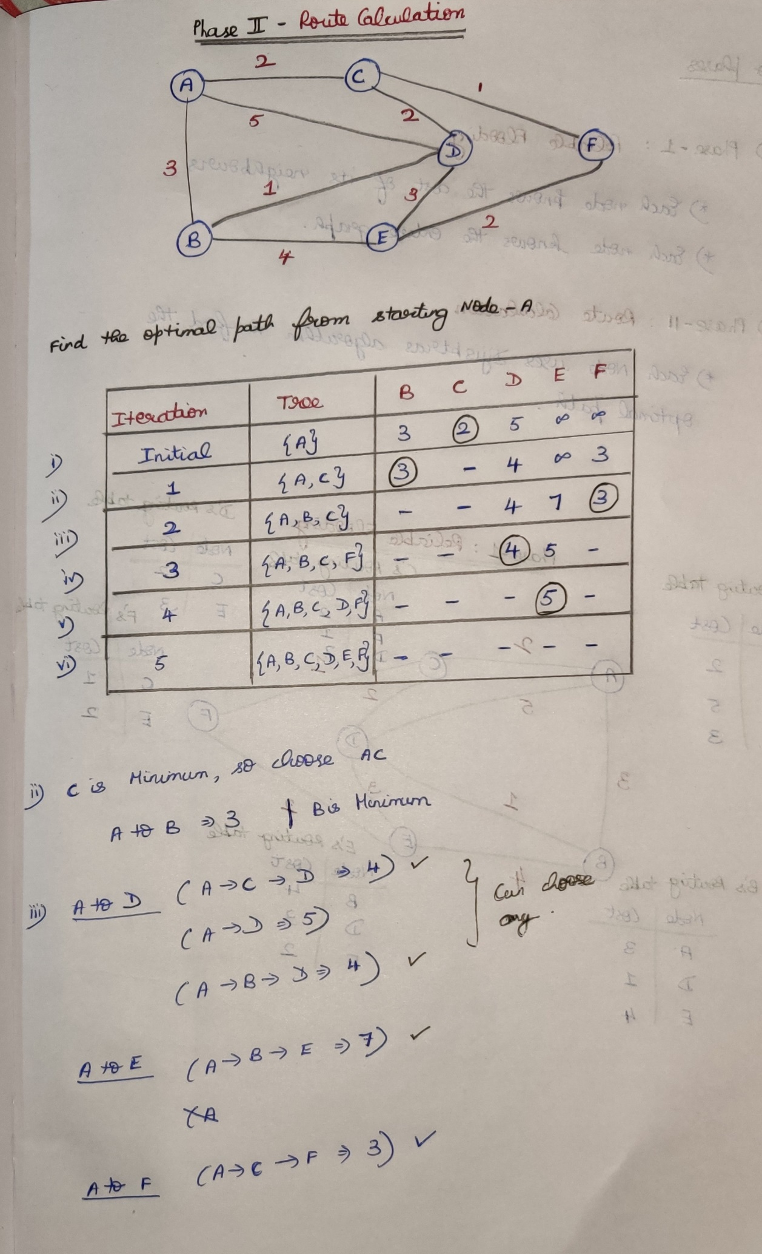

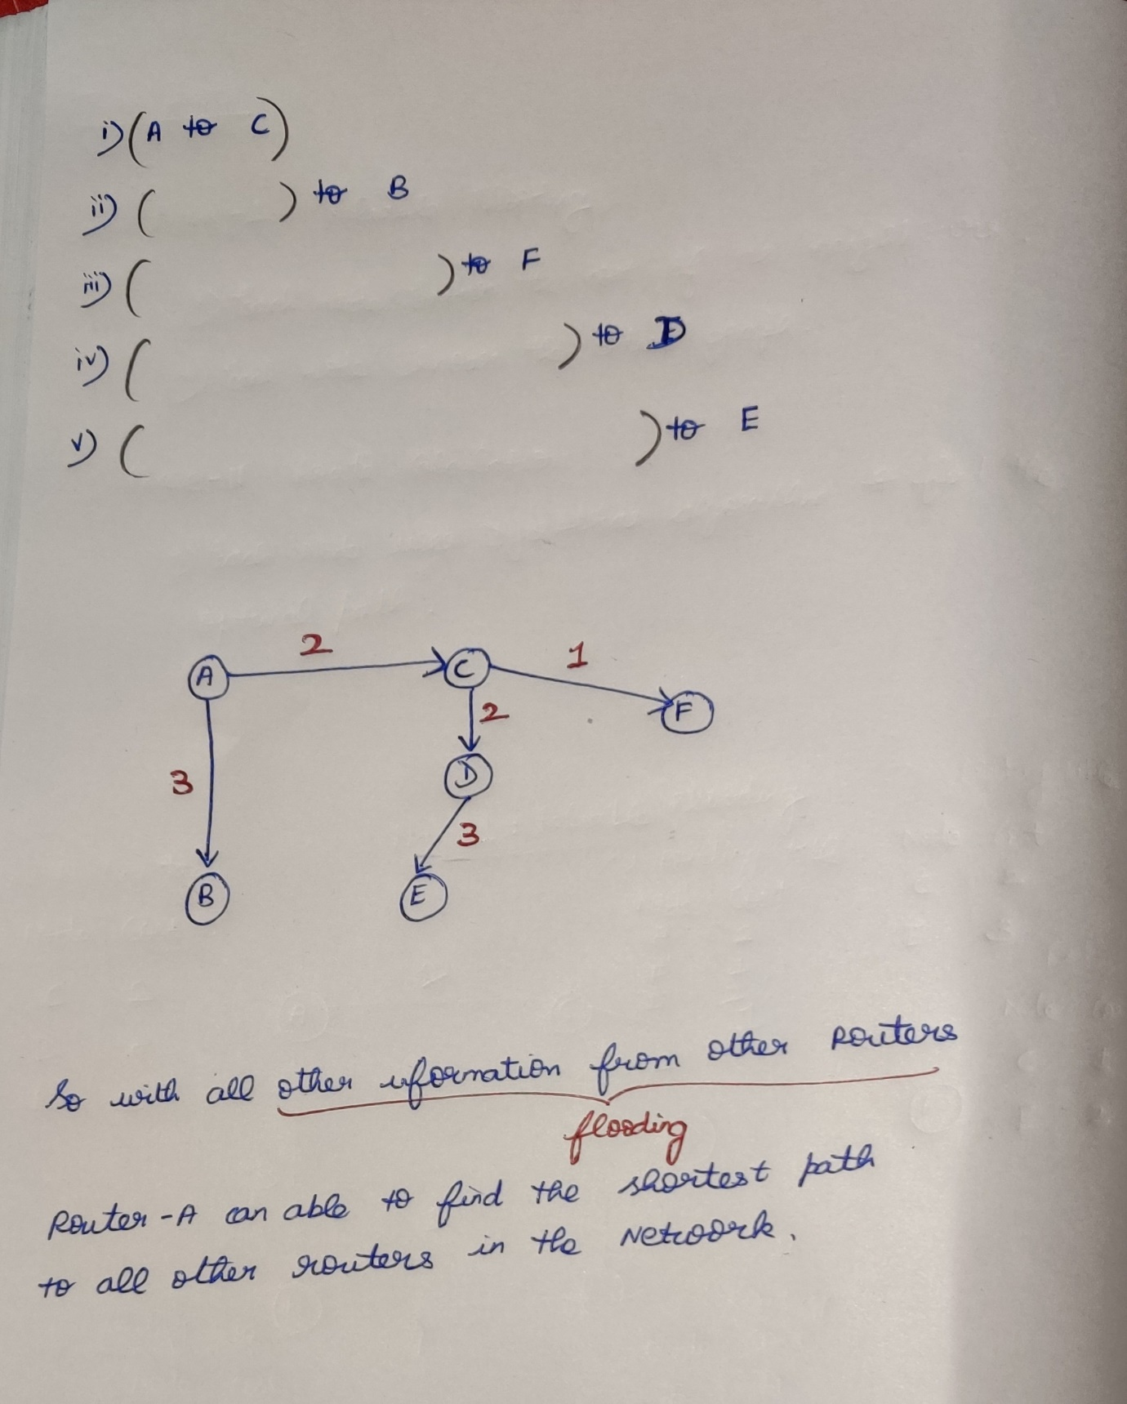

**Question**

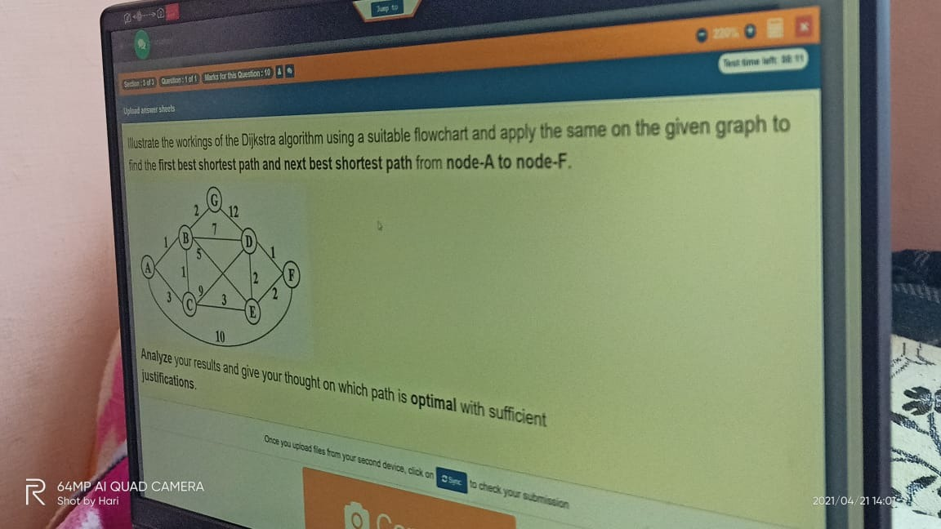

### **Difference between Distance Vector Routing and Link State Routing**

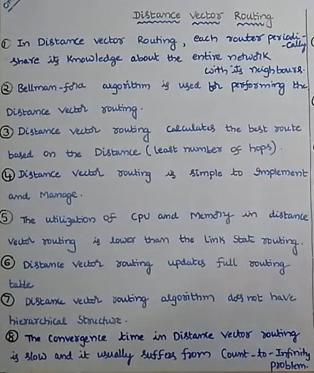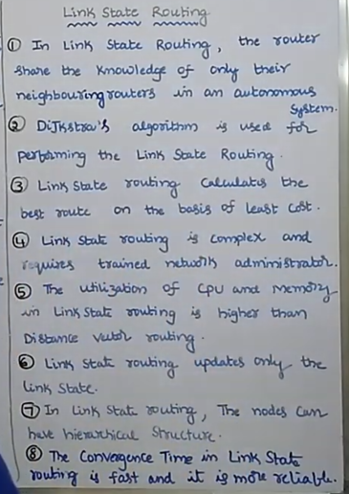



Will send the Entire routing table Will send only the link-state information  
to the nearest neighbour. to the nearest neighbour.



## **Inter-domain**

### **Path-vector [BGP]**